Summer is here! But that is no reason not to study English. When you have some free time, why not do one of these things:

Read an English book
Here are some books you can read. You can find the pdf files of the books here: https://drive.google.com/drive/folders/1wj59G06sLhxMxcL-YgkxDunlmFG4QdgX?usp=sharing
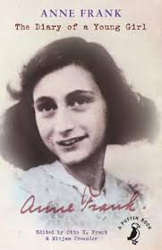
The Diary of a Young Girl
The Diary of a Young Girl is among the most enduring documents of the 20th century. Anne Frank kept a diary from 1942 to 1944. Initially she wrote it strictly for herself. Then, one day in 1944, a member of the Dutch government in exile announced in a radio broadcast from London that after the war he hoped to collect eyewitness accounts of the suffering of the Dutch people under the German occupation, which could be made available to the public. As an example, he specially mentioned letters and diaries. Anne Frank decided that when the war was over, she would publish a book based on her diary. Anne's diary ends abruptly when she and her family were betrayed.
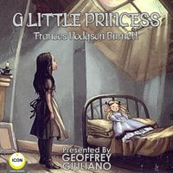
A Little Princess
Alone in a new country, wealthy Sara Crewe tries to settle in and make friends at boarding school. But when she learns that she'll never see her beloved father gain, her life is turned upside down. Transformed from princess to pauper, she must swap dancing lessons and luxury for hard work and a room in the attic. Will she find that kindness and genorosity are all the riches she truly needs?

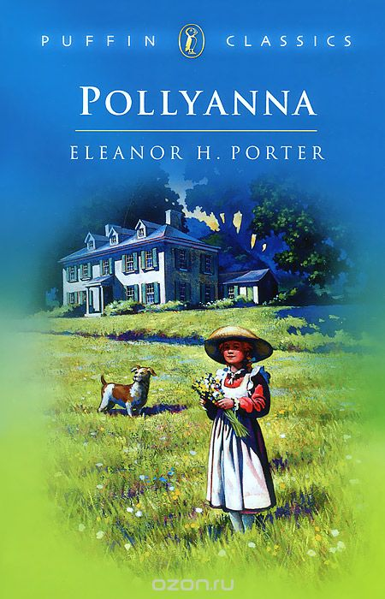
Pollyanna
As soon as Pollyanna arrives in Beldingsville to live with her strict and dutiful maiden aunt, she begins to brighten up everybody's life. The 'glad game' she plays, of finding a silver lining in every cloud, transforms the sick, the lonely and the plain miserable - until one day something so terrible happens that even Pollyanna doesn't know how to feel glad about it.
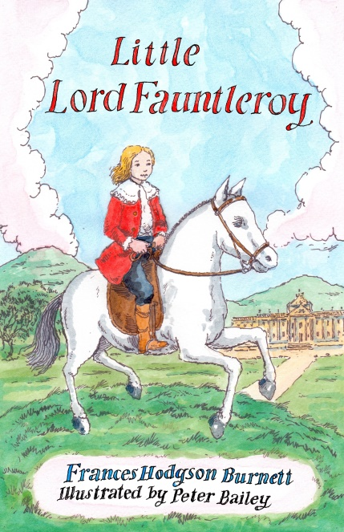
Little Lord Fauntleroy

The story of a small, angelic boy from New York who is told he is the heir to an English earldom and is whisked away to the English countryside where he begins to win over his bad-tempered old grandfather. When the boy's identity is challenged, his old friends from New York come to his rescue.

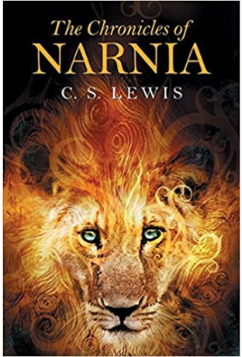
The Chronicles of Narnia
Epic battles between good and evil, fantastic creatures, betrayals, heroic deeds, and friendships won and lost all come together in this unforgettable world, which has been enchanting readers of all ages for over sixty years.

Watch a film
- The Pursuit of Happiness ("В погоне за счастьем" (2006) на английском с субтитрами онлайн | Filmatika.ru - Фильмы в оригинале и переводе на другие языки)
- The King’s Speech ("Король говорит!" (2010) на английском с субтитрами онлайн | Filmatika.ru - Фильмы в оригинале и переводе на другие языки)
- Forrest Gump ("Форрест Гамп" (1994) на английском с субтитрами онлайн | Filmatika.ru - Фильмы в оригинале и переводе на другие языки)
- Hidden Figures (Скрытые фигуры на английском с субтитрами (lelang.ru))
- Freedom Writers (Писатели свободы на английском с субтитрами (lelang.ru))
- Hacksaw Ridge (По соображениям совести на английском языке с субтитрами (lelang.ru))
- The Theory of Everything (Вселенная Стивена Хокинга на английском языке с субтитрами (lelang.ru))
- Pay It Forward (Заплати другому на английском языке с субтитрами (lelang.ru))
- Green Book (Зелёная книга на английском языке с субтитрами (lelang.ru))
- Fantastic Beasts and Where to Find Them (Фантастические твари и где они обитают на английском языке с субтитрами (lelang.ru))
- Dead Poet Society (Общество мертвых поэтов на английском языке с субтитрами (lelang.ru))
- Miss Peregrine s Home For Peculiar Children (Дом странных детей Мисс Перегрин на английском языке с субтитрами (lelang.ru))
- Schindler’s List (Список Шиндлера на английском языке с субтитрами (lelang.ru))
- What Dreams May Come (Куда приводят мечты на английском языке с субтитрами в HD (lelang.ru))
- The Boy in the Striped Pajamas (Мальчик в полосатой пижаме / The Boy in the Striped Pyjamas (2008) HD 720 - фильм онлайн (rus, eng) (english-films.co))

